**Dark ‘n Stormy**

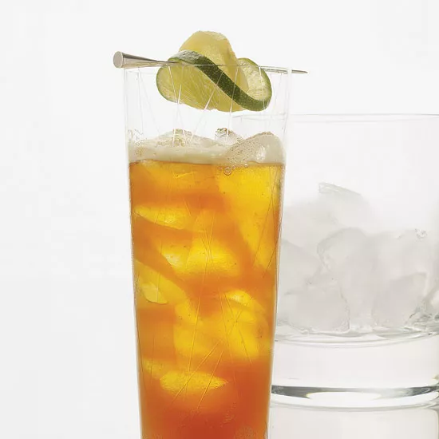

**INGREDIENTS**

2 ounces dark rum (preferably Gosling's)

½ ounce fresh lime juice (optional)

Ice

1 candied ginger slice

3 ounces chilled ginger beer

1 lime wheel

**METHOD**

1. Fill a cocktail shaker with ice. Add the rum and lime juice and shake well. Strain into an ice-filled collins glass. Stir in the ginger beer. Skewer the ginger slice and lime wheel and garnish the cocktail.